Exhibit 14: Live Environment Testing and Validation
  - Petitioner: Samuel Gbli Tetteh
  - NIW Proposed Endeavor — Live deployment and validation across all three pathways (Pathway 1: context-aware identity anomaly detection; Pathway 2: OT/ICS intrusion detection; Pathway 3: automated compliance validation).

1. Purpose
In my personal statement I committed not only to building these systems but to demonstrating that they operate in a real, running environment. This exhibit provides that evidence: it documents how I validated the systems developed in Exhibits 11–13 in a live deployment rather than only in offline notebooks. Containerized test sources continuously stream synthetic-but-realistic events into the live scoring API, and each model's decisions are recorded and measured as the events arrive. Section 8 reports the measured results from an actual run; the earlier sections give the reproducible procedure, and the figures throughout show the running system and its output as captured on screen.

2. System Architecture Under Test
A single containerized FastAPI backend (container name: RedMap) hosts all three models and exposes them on http://localhost:2500. Two supporting repositories provide the live inputs, each feeding a different part of the project:
- live-target-lab – two standing Docker services that continuously POST synthetic login events to the Identity Anomaly endpoint (/identity/score) and synthetic sensor telemetry to the OT/ICS endpoint (/ics/score). This is the live source for both machine-learning detection models.
- cloud-target-lab – a LocalStack-simulated AWS account (S3, EC2, IAM) containing deliberately insecure and properly configured resources. This is the live target scanned by the Control Advisor NIST 800-53 recommendation tool.
- RedMap (backend) – receives each event, runs the relevant model, and returns a verdict. It is the live system under test; the event sources are clients that stream data at it.
The two labs are not interchangeable: login and sensor data come only from live-target-lab, while the cloud lab exists solely for the control-scanning tool.

3. How Logging Works – Who Records What
Two different kinds of log are produced, and the distinction matters for how results are measured:
- RedMap (the backend) logs HTTP traffic only — e.g. 'POST /identity/score 200 OK'. It is a stateless scorer: it receives an event, returns a verdict in the HTTP response, and does not itself record whether the event was anomalous. It also has no knowledge of whether an event was 'supposed' to be normal or suspicious.
- Each event source logs the detection result — because it alone holds both halves of the comparison: what it intended the event to be (injected normal / suspicious / attack) and the verdict it received back from RedMap (OK / ALERT, with the score). This combined line is what makes measurement possible.
Representative RedMap access log (backend plumbing — not the detection result):
INFO: 172.17.0.1 - "POST /identity/score HTTP/1.1" 200 OK
INFO: 172.17.0.1 - "POST /ics/score HTTP/1.1" 200 OK

Because the detection results live in the event-source logs, those are the logs that are saved and tallied in Section 8.

4. Prerequisite – Start the Backend API
All live sources target http://localhost:2500 (host port 2500 mapped to the container's port 8000). Start it and confirm it is serving:
docker start RedMap
curl.exe -s http://localhost:2500/health

A healthy service returns {"status": "ok"}. Interactive API documentation is available in a browser at http://localhost:2500/docs.
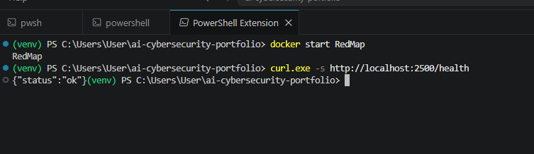
Figure 1. Starting the backend and confirming health — 'docker start RedMap', then a request to /health returns {"status": "ok"}.
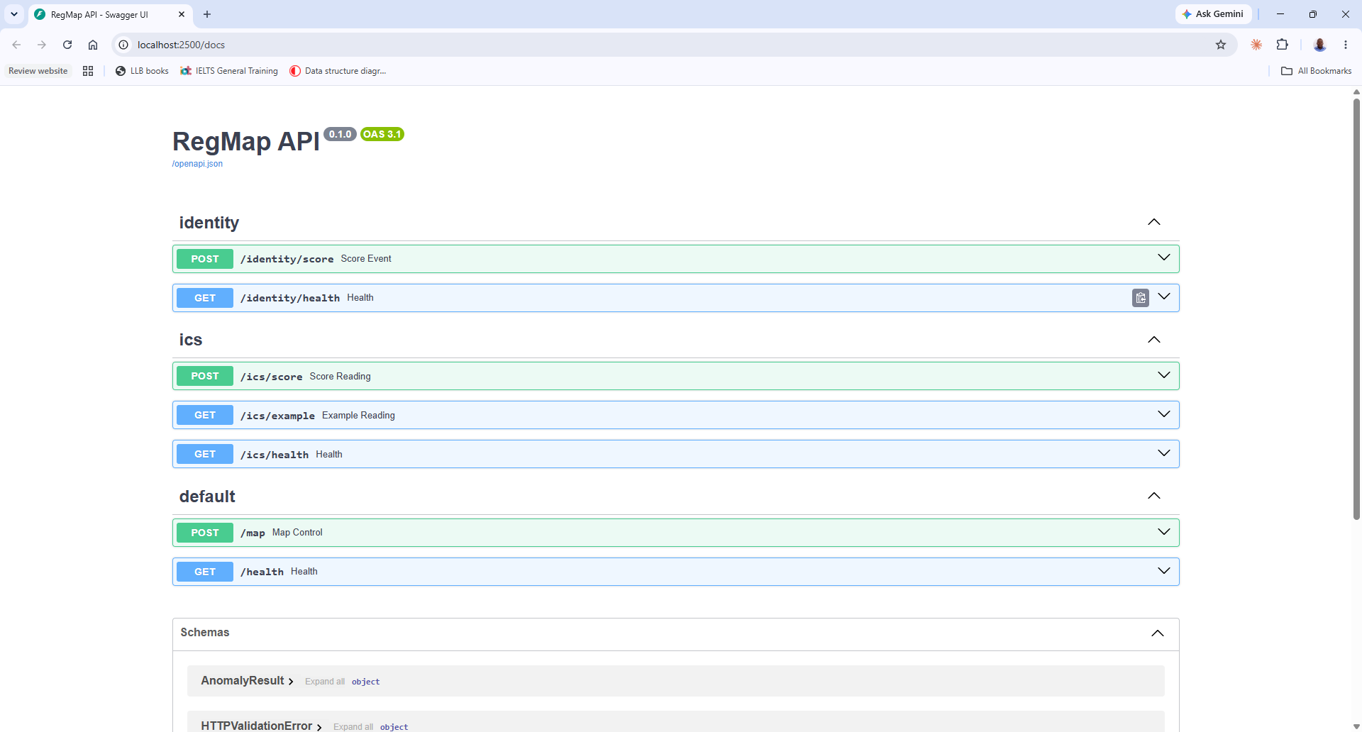
Figure 2. The interactive API documentation (Swagger UI) at http://localhost:2500/docs, exposing the identity, ics, and map endpoints of the RedMap backend.
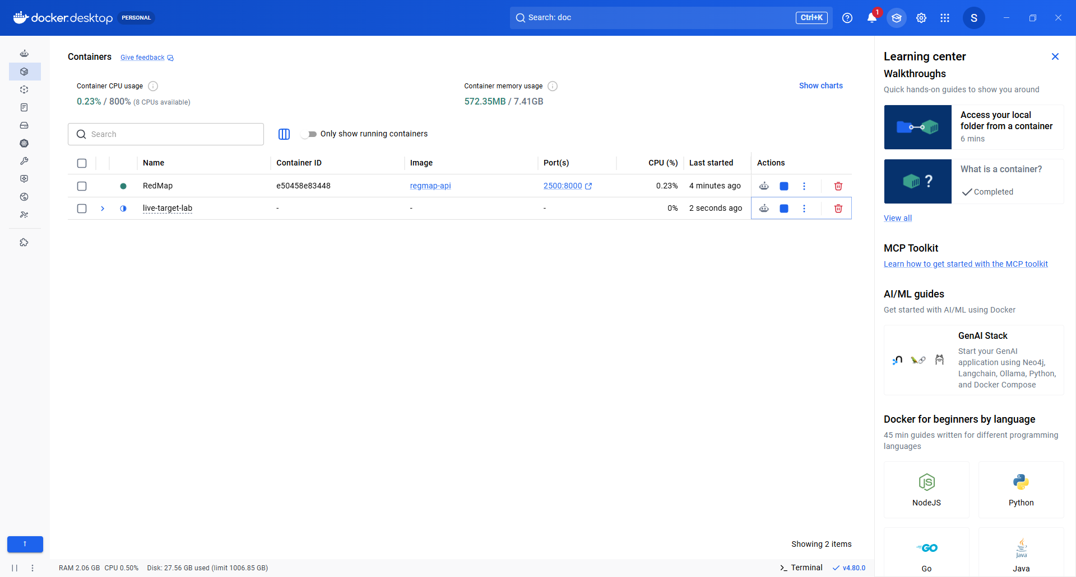
Figure 3. Docker Desktop showing the RedMap backend (image regmap-api, port 2500 → 8000) and the live-target-lab event sources running.

5. Test 1 – Identity Anomaly Detection on Live Logins
Start the live login source and follow its output:
cd C:\Users\User\live-target-lab
docker compose up -d identity-event-source
docker logs -f identity-event-source

Normal traffic is single logins from ordinary users. An attack is modelled the way the detector actually recognizes one: a behavioural burst — a single account rapidly authenticating across many different machines in a short window (classic credential-stuffing / lateral movement). This drives the model's behavioural features (login volume and number of distinct machines), which is the same signal that made the ANONYMOUS LOGON account the top anomaly in the original training data. A lone event that only alters categorical fields sits near the decision boundary and is not reliably anomalous; the breadth of access is what matters, so that is what is simulated.
Each line shows what the event was intended to be and the verdict the model returned. A normal login and a burst of attack logins from one account:
[16:58:27] OK (injected normal) :: U1006@DOM1 on C1028 (Negotiate/Network, Success) score=0.234
[16:58:42] ALERT (injected suspicious) :: guest@DOM1 on C1047 (TotallyUnrecognizedAuth/RemoteInteractive, Fail) score=-0.025
[16:58:43] ALERT (injected suspicious) :: guest@DOM1 on C1038 (LegacyProtocolXYZ/NewCredentials, Fail) score=-0.015
[16:58:43] ALERT (injected suspicious) :: guest@DOM1 on C1021 (UnverifiedCustomAuth/RemoteInteractive, Fail) score=-0.028
[16:58:43] ALERT (injected suspicious) :: guest@DOM1 on C1007 (TotallyUnrecognizedAuth/NewCredentials, Fail) score=-0.014

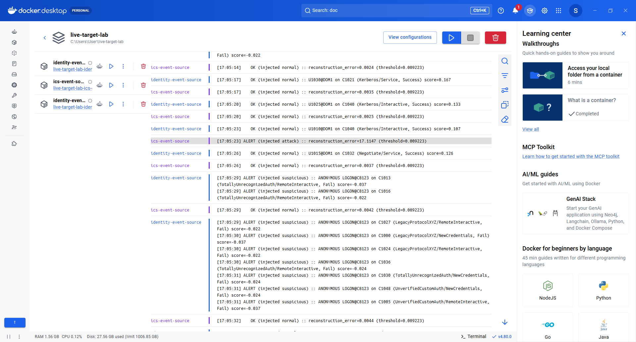
Figure 4. Live identity detection — a burst of logins from one account (ANONYMOUS LOGON) across many machines is scored ALERT, while ordinary single logins are scored OK. This is a combined live view, so the OT/ICS readings appear interleaved.

6. Test 2 – OT/ICS Intrusion Detection on Live Telemetry
Start the live sensor source and follow its output:
cd C:\Users\User\live-target-lab
docker compose up -d ics-event-source
docker logs -f ics-event-source

Normal readings perturb a real recorded sensor baseline with small noise; roughly 15% inject a large spike on one to three sensors, simulating a cyber-physical attack or equipment fault. Each line reports the reconstruction error against the detection threshold (0.009223):
[16:44:41] OK (injected normal) :: reconstruction_error=0.0039 (threshold=0.009223)
[16:44:47] OK (injected normal) :: reconstruction_error=0.0047 (threshold=0.009223)
[16:44:44] ALERT (injected attack) :: reconstruction_error=34.4534 (threshold=0.009223)
[16:44:57] ALERT (injected attack) :: reconstruction_error=29.6897 (threshold=0.009223)

The separation is dramatic — normal readings score around 0.004 while attacks score 29–34, roughly three thousand times the threshold — which is the live evidence that the autoencoder distinguishes attacks from normal operation.

Figure 5. Live OT/ICS detection — injected sensor attacks are scored ALERT (reconstruction error far above the threshold) while normal readings are scored OK. This is a combined live view, so the identity logins appear interleaved.

7. Test 3 – Control Advisor Against a Simulated Cloud Account
The cloud-target-lab provides a live but safe AWS environment (via LocalStack) for the Control Advisor tool to scan. Start the environment, seed and verify test resources, then scan them:
cd C:\Users\User\cloud-target-lab
docker compose up -d
.\.venv\Scripts\python.exe seed.py
.\.venv\Scripts\python.exe verify.py

cd C:\Users\User\ai-cybersecurity-portfolio
.\venv\Scripts\python.exe control-advisor\scanner\cloud_scan.py --endpoint-url http://localhost:4566 --access-key test --secret-key test

A correct scan flags the deliberately insecure resources and leaves the properly configured ones unflagged:
- Flagged: the public-read S3 bucket (acme-public-uploads), the security group with SSH open to 0.0.0.0/0 (sg-insecure-ssh), and the admin-equivalent IAM user (svc-legacy-app).
- Not flagged: the private bucket (acme-internal-backups), the restricted web security group (sg-secure-web), and the scoped read-only IAM user (alice-analyst).
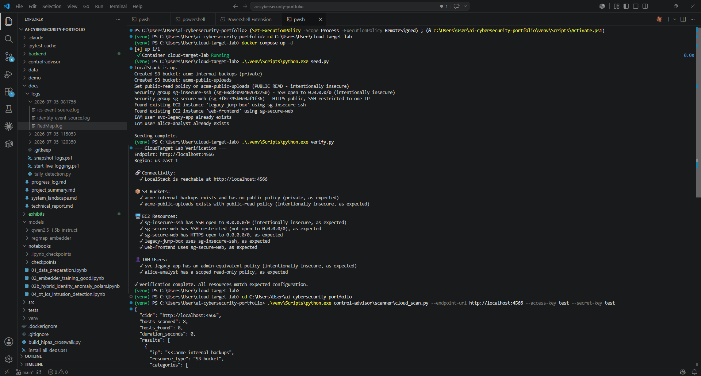
Figure 6. Seeding and verifying the simulated AWS account, then running the Control Advisor cloud scan against it.
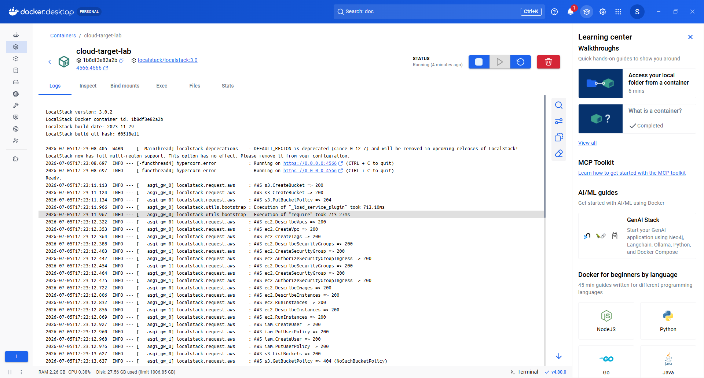
Figure 7. The cloud-target-lab (LocalStack) container logs, showing the simulated AWS S3, EC2, and IAM API calls.

8. Validation Results (Measured)
The following results are from a live run recorded on 2026-07-05, with the backend running the current code and the two event sources streaming continuously. The event-source logs were saved and scored with a tally utility (docs/logs/tally_detection.py) that compares each event's intended label against the model's actual verdict. Definitions: recall = fraction of injected anomalies the model flagged; specificity = fraction of normal events correctly left un-flagged; precision = fraction of alerts that were real anomalies.
Model | Events | Recall | Specificity | Precision | Accuracy
Identity Anomaly | 199 | 100.0% | 100.0% | 100.0% | 100.0%
OT/ICS Intrusion | 382 | 100.0% | 99.4% | 96.4% | 99.5%

Identity: of 116 injected attack logins (behavioural bursts), all 116 were flagged, with zero false alarms across 83 normal logins. OT/ICS: of 53 injected attacks, all 53 were flagged; 2 of 329 normal readings produced a false alert (99.4% specificity). Both models therefore detect live anomalies as they arrive, with high precision.
The tally is reproducible from the saved logs with:
python docs\logs\tally_detection.py docs\logs\<snapshot-folder>
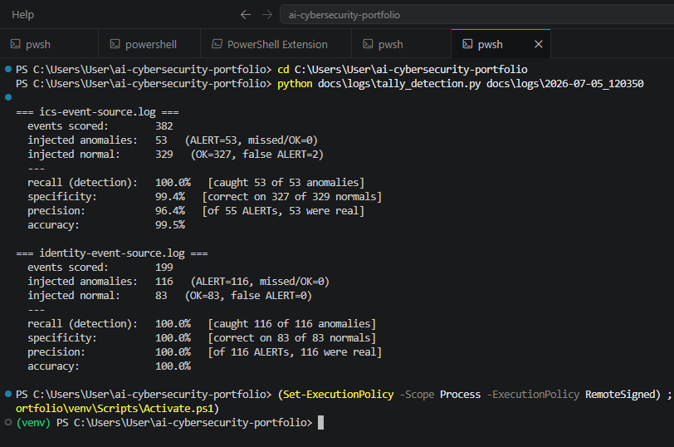
Figure 8. Tally output — recall, specificity, precision, and accuracy computed from the saved event-source logs.

9. Path to Real-Time Operational Decisioning
The validation above proves the detection itself works in real time. Turning detection into automated operational response is a natural next stage, structured as three additive layers on top of the existing scorer (the model is unchanged; memory and actions are added around it):
- Record — RedMap persists each verdict it produces (timestamp, input summary, is_anomaly, score) to a durable store, so there is an authoritative real-time trail independent of any test client. This is the foundational step.
- Decide — a policy layer evaluates verdicts against rules (for example: any anomaly, or repeated anomalies from one account within a window) to determine which warrant action.
- Act — the decision triggers a response: alert a security analyst, require step-up authentication, disable an account, open a ticket, or page on-call.
These can be arranged inline (RedMap acts immediately after scoring) or decoupled (RedMap emits verdicts to a stream consumed by a separate decision service). The decoupled arrangement is the more production-grade pattern because decision logic can evolve independently of the model. This roadmap is documented here as the planned deployment trajectory; the detection capability it builds on is already demonstrated and measured above.

10. Success Criteria – “Working as Expected”
The live environment is considered validated when all of the following hold:
- The backend and both live-source containers appear as running in Docker Desktop.
- Identity: injected behavioural-burst attacks are scored ALERT and normal logins OK (measured: 100% recall, 100% specificity).
- OT/ICS: injected attacks are scored ALERT and normal readings OK (measured: 100% recall, 99.4% specificity).
- Control Advisor: the cloud scan flags all intentionally insecure resources and none of the properly configured ones.

11. Summary
This exhibit demonstrates that the three systems operate correctly as live, containerized services rather than offline prototypes: each receives data as it arrives and produces correct, measured anomaly and control-gap determinations in real time. The measured results in Section 8, together with the figures throughout, provide direct evidence of the running environment and its expected behavior, and Section 9 sets out the path from live detection to automated operational response.

